ASSIGNMENT – I

DOMAIN : IoT

PROJECT TITLE: Smart Farmer – IOT Enabled Smart Farming Application

Name: DEVISHREE.N (713319EC020)

ASSIGNMENT TITLE: SMART HOME

SMART Home Circuit Connection: 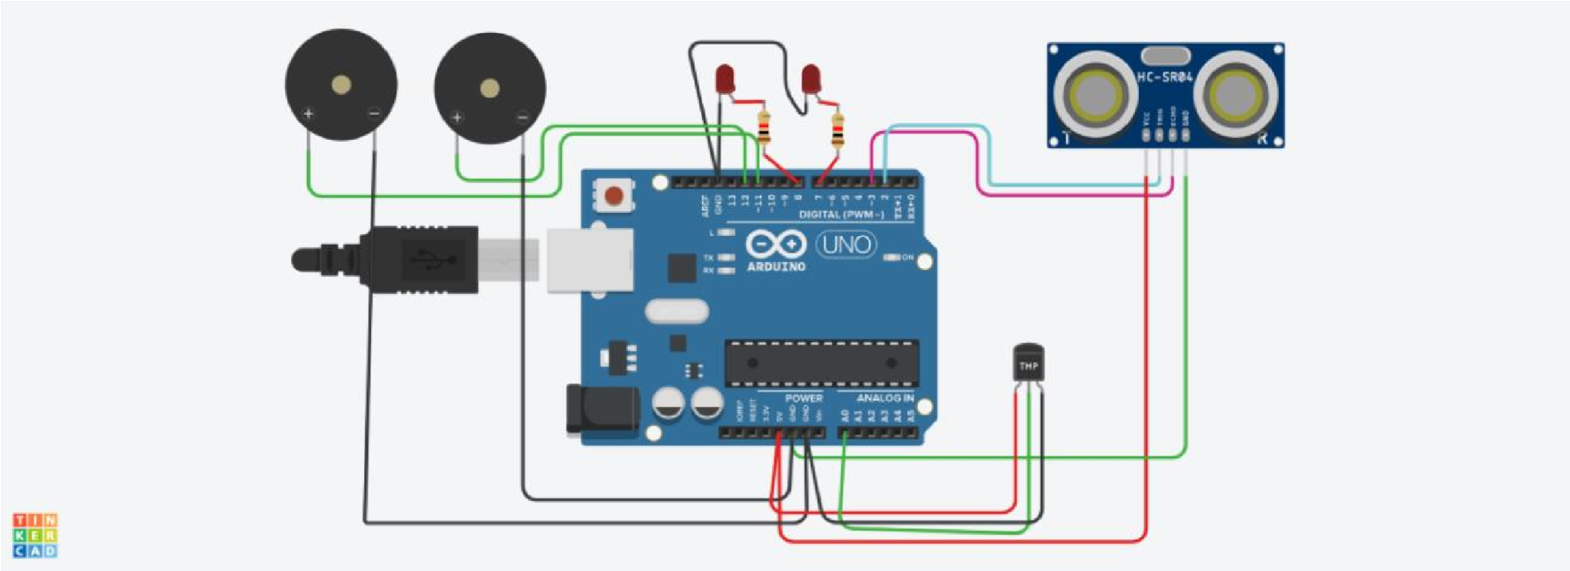

Components Used:

i)2 Piezo Buzzers ii)Temperature Sensor iii)Ultrasonic Sensor iv)LED -2

v)Resistor-2

Code :

int t=2; int e=3;

void setup() {

Serial.begin(9600); pinMode(t,OUTPUT); pinMode(e,INPUT); pinMode(12,OUTPUT);

} void loop() {

//ultrasonic sensor digitalWrite(t,LOW); digitalWrite(t,HIGH); delayMicroseconds(10); digitalWrite(t,LOW); float dur=pulseIn(e,HIGH); float dis=(dur\*0.0343)/2;

Serial.print("Distance is: ");

Serial.println(dis);

//LED ON if(dis>=100)//(in terms of centimeter)

{

digitalWrite(8,HIGH); digitalWrite(7,HIGH);

}

//Buzzer For ultrasonic Sensor if(dis>=100)

{

for(int i=0; i<=30000; i=i+10)

{ tone(12,i); delay(1000); noTone(12); delay(1000);

} }

//Temperate Sensor double a= analogRead(A0); double t=(((a/1024)\*5)-0.5)\*100;

Serial.print("Temp Value: "); Serial.println(t); delay(1000); //LED ON if(t>=100)//(in terms of celsius)

{

digitalWrite(8,HIGH); digitalWrite(7,HIGH);

}

/Buzzer for Temperature Sensor if(t>=100)

{

for(int i=0; i<=30000; i=i+10)

{

tone(12,i); delay(1000); noTone(12); delay(1000);

} }

//LED OFF if(t<100)

{

digitalWrite(8,LOW); digitalWrite(7,LOW);

}

}

TINKERCAD LINK:

https://www.tinkercad.com/things/beGCQEVAPBM-smart-home/editel?sharecode=6BPXGhDdU8fkeMH9U6ydR68GCAOp-P3XYC1rLQMqbw